**Hospitals for Texas Motor Speedway SMX**

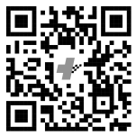

**Texas Health Harris Methodist Hospital Alliance**

**Emergency Department - Level III Trauma**

**10864 Texas Health Trail**

**Fort Worth, TX 76244**

**682-212-2000**

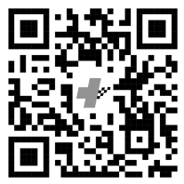

**Texas Health Harris Methodist Hosp**

**Level I Trauma Center Adult & Peds**

**1301 Pennsylvania Ave**

**Fort Worth, TX 76104**

**817-250-2000**

**Primary Trauma Center**

**John Peter Smith Hospital**

**Level 1 Trauma  
1500 S. Main Street**

**FORT WORTH, TX 76104**

**(817) 702-3431**

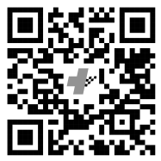

**Secondary Trauma Center**

