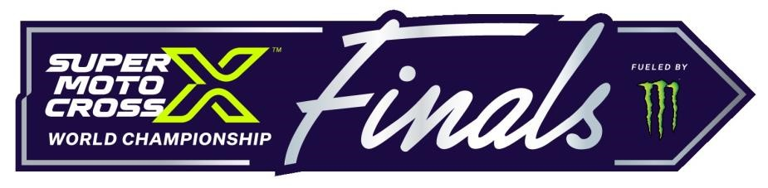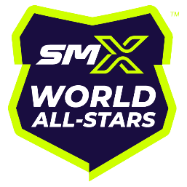

**2024 SMX World All-Stars Supplemental Rules**

**Schedule:**

**65cc World All-Stars**

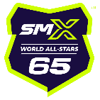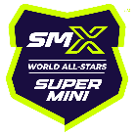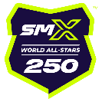

September 7: zMAX Dragway at Charlotte Motor Speedway, Concord, NC

**Supermini World All-Stars**

September 14: Texas Motor Speedway, Fort Worth, TX

**250 World All-Stars**

September 21: The Strip at Las Vegas Motor Speedway, Las Vegas, NV

**Eligibility:**

* **65cc World All-Stars**: Top 5 finishing racers from **65cc (10-11)** (Class 27) at the 2024 AMA Amateur National Motocross Championship at Loretta Lynns.
* **Supermini World All-Stars**: Top 5 finishing racers from **Supermini 2 (13-16)** (Class 33) at the 2024 AMA Amateur National Motocross Championship at Loretta Lynns.
* **250 World All-Stars**:
  + Top 5 finishing racers from **250 Pro Sport** (Class 2) at the 2024 AMA Amateur National Motocross Championship at Loretta Lynns;
  + Top 5 finishing racers from **250 B** (Class 4) at the 2024 AMA Amateur National Motocross Championship at Loretta Lynns; and
  + Top 5 finishing racers from **250 Futures** class at the 2024 AMA Supercross Futures National Championship in Salt Lake City.
* All qualified racers must remain eligible throughout the day of the event to compete.
* The remaining competitors will be invitational based on results from major events worldwide.

**Rules:**

* The 2024 AMA Racing Rules and approved Motocross Equipment standards apply, subject to the following supplemental rules, which are subject to change in the sole discretion of the SMX League.
* Modified machines permitted.

**Class Descriptions:**

* **65cc World All-Star Class**

Displacement: 59-65cc 2-Stroke

Minimum Wheel Size 12”; Maximum Front 14”

Maximum Wheelbase: 45.5”

Age (9-11)

* **Supermini World All-Star Class**

Displacement: 79-112cc 2-Stroke/79-150cc 4-Stroke Maximum Wheel Size: Front 19”; Rear 16”

Age (12-16)

* **250 World All-Star Class**

Displacement: 250cc 4-Stroke

Age (14+)

A & B classified riders only

**Non-Eligibility:**

* The following professional licensed racers (Pro Motocross or Pro Supercross) are **NOT** eligible to participate in the 250 World All-Star Class:
  + Racers competing in the Final 40 in Pro Motocross (250 or 450 class) in more than three Pro Motocross events per year in the current or previous year;
  + Racers competing in the Final 40 in Pro Supercross (250SX or 450SX class) in the current or previous year; or
  + Racers competing in the Final 40 in an FIM MXGP or MX2 Grand Prix event outside of the United States in the current or previous year.

**AMA Membership:**

* AMA membership is required to compete; Proof of membership must be presented at registration upon request.

**Medical Insurance:**

* Medical insurance is required to compete; Proof of coverage must be presented at registration upon request.

**Registration:**

* Online registration is required. Invited riders will receive an invitation email with a registration link; Registration must be completed prior to expiration of the link.
* Event On-Site registration is required. Although pre-entered, riders must check-in at Industry Will Call to complete their registration.
* Photo ID may be required at event registration.
* The registration fee is $200 per class and includes a Rider Pass (includes paddock access, industry seating if available & track access at designated times).

**Technical Inspection:**

* Motorcycles must be presented at technical inspection.
* Frame numbers will be assigned by the AMA at technical inspection.
* Transponders will be provided at technical inspection. Failure to return the transponder will result in a charge of $400. Transponder holders will be available for purchase at Technical Inspection for $10.
* The official *SuperMotocross World All-Stars* logo must appear on the front number plate. Organizer will provide the front number plate decal or you may download online

**Race Program:**

* The Race Program will consist of:
  + (2) Free Practice Sessions on Friday @ 10 minutes ea.
  + (2) Timed Qualifying Sessions on Saturday for gate selection @ (10) minutes ea. o (1) Main Event @ 8 minutes + (1) Lap
* Maximum (22) riders will compete in the Main Event.

**Flags:**

* **Yellow Flag or Yellow Flashing Light:** Passing and Jumping permitted; proceed with extreme caution.
* **White Flag with Red Cross or Red Flashing Light:** No Passing or Jumping; proceed with extreme caution.

**Awards:**

* Top-3 Finishers will receive awards and podium interviews.

**Mechanics:**

* One Mechanic per rider permitted on the Start Line.
* Mechanics must purchase a Mechanics Pass.
* Mechanics Passes provide all-day paddock access, Industry Seating, & track access at designated times.
* Mechanics must check-in at Industry Will Call to receive their Mechanics Pass.
* To purchase a Mechanics Pass, contact pmurphy@feldinc.com

**Industry Passes:**

* Family members and guests may purchase Industry Passes.
* Industry Passes provide all-day paddock access and Industry Seating only if available.
* Industry Passes must be picked-up at Industry Will Call.
* To purchase Industry Passes, contact pmurphy@feldinc.com

**Refund Policy:**

* Refund requests must be in writing and sent to sxfrefunds@feldinc.com no later than seven (7) days before the event. Refunds will not be accepted after that deadline.

**Additional Information:**

* For additional information, contact sxfinfo@feldinc.com